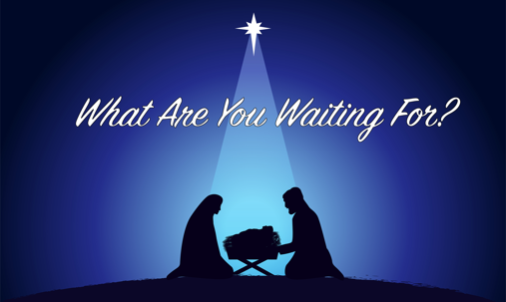

Discipleship Guide — HOPE: Waiting for God to Move

Opening Question
Think about a time when you were waiting for something to change—your circumstances, a relationship, your health, your job, or even your own heart.
What made the waiting hard, and what helped you hold on during that season?

1. Hope Begins in the Dark
Read Isaiah 9:2
Isaiah speaks to a people walking in darkness—political chaos, spiritual confusion, and deep fear. Hope doesn’t start when everything is bright; it starts in the dark, when we feel the weight of our need.

Discussion
- Where do you sense “darkness” in your life, community, or world right now?
- Why do you think God often begins His work before we can see it?
- What does it mean for hope to be an expectation, not just a feeling?

2. Hope Has a Name
Read Isaiah 9:6–7
Isaiah doesn’t just promise light—he promises a Person:
Wonderful Counselor, Mighty God, Everlasting Father, Prince of Peace. Hope is not a wish; hope is rooted in who Jesus is and what He brings.

Discussion
- Which name of Jesus stands out to you most in this season? Why?
- How does remembering who Jesus is strengthen your hope?
- Where do you need His wisdom, power, or peace right now?

3. Hope Fills Us as We Trust God
Read Romans 15:13
Hope isn’t something we try to manufacture. God fills us with hope as we trust Him. Waiting becomes worship when we choose to depend on Him.

Discussion
- What helps you trust God when you don’t see movement yet?
- What drains your hope most quickly?
- How can the group pray for you to trust God in a specific area of waiting?

Practical Application for This Week
Identify one area where you are waiting for God to move.
Each day this week, pray Romans 15:13 over that situation and ask God to fill you with renewed hope. Share a update with someone in your group by the end of the week.

Closing Prayer
“God of hope, fill us with all joy and peace as we trust You. Help us to see Your light in our darkness, to believe Your promises, and to wait with expectant hearts. We trust that You are already at work. Amen.”

