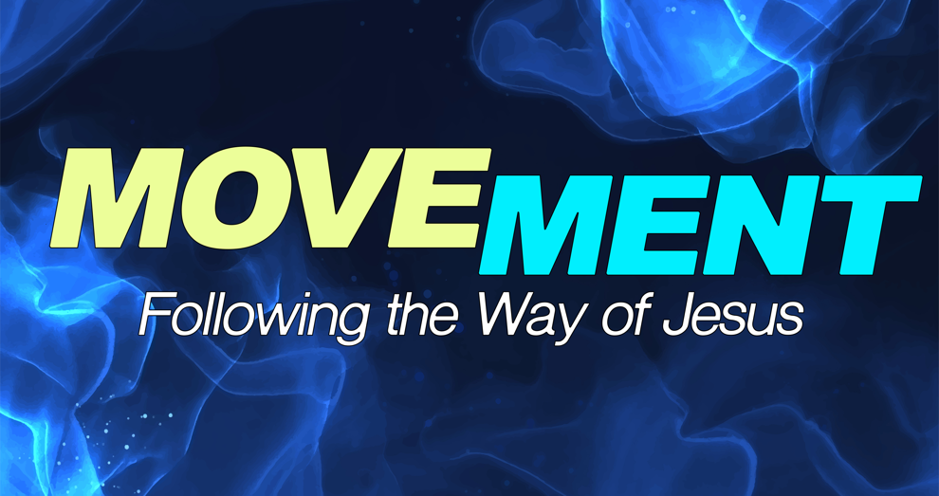

Movement Week 1: Discipleship Guide

In this new series we are beginning to look at the call of the follower beyond the resurrection. Each of us has a “mission field” — a circle of influence. And the Great Commission calls us to be faithful where we are. The Great Commission isn’t a task for a few; it is our purpose for the Church. It’s why we’re here.

Scripture Focus: Matthew 28:5–10, 16–20

1. Why is obeying the Great Commission an issue of Jesus’ worth or authority in your life? Why should worship fuel our obedience to the Great Commission?
2. If making disciples is a command, how do you see yourself doing this? In your home, work, recreation, church, etc?
3. Why is the local church so important when it comes to obeying the Great Commission?
4. How can you be more intentional about using your gifts, resources, and desires for the Great Commission? How can you embrace where God has placed you and how he has equipped you at this time for the Great Commission?