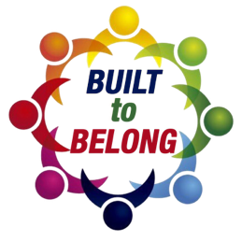

Discipleship Guide Week 3

Title: Community
Scripture: Romans 12:1–21
Theme: Mercy transforms how we live, love, and lead in community.

Discussion:
- What does it mean to offer your body as a “living sacrifice”?
- How is humility essential to healthy community?
- How do spiritual gifts function in a merciful, humble community?
- Where are you tempted to compare your gifts to others?
- How can you use your gifts to build up others this week?
- What’s the difference between “nice” and “genuine love”?
- What do verses 10–13 teach us about day-to-day love in community?
- Who in your community needs more than just polite kindness—they need your time, hospitality, or presence?
- What does it look like to “bless those who persecute you”?
- How is peacemaking an act of mercy?

Application:
- Is there someone you need to forgive, bless, or pursue peace with?
- What makes pursuing peace difficult—and how does mercy help?

