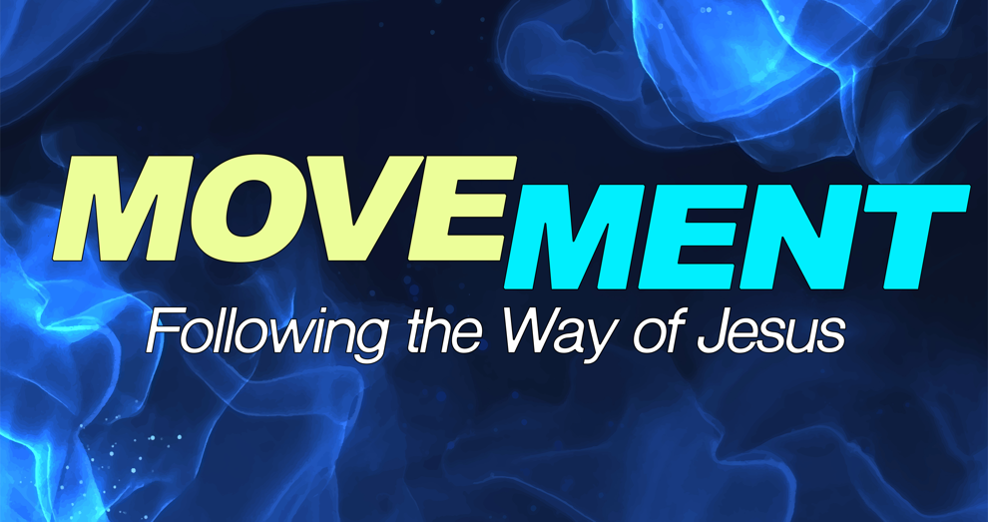
Movement Week 5: Discipleship Guide

In this new series we are beginning to look at the call of the follower beyond the resurrection. Each of us has a “mission field” — a circle of influence. And the Great Commission calls us to be faithful where we are. The Great Commission isn’t a task for a few; it is our purpose for the Church. It’s why we’re here.
Scripture Focus: Matthew 18:18-20
We are a movement of Christ's love, building an authentic community of grace and belonging. (Our Vision FYI). How do we live this out?

- How does understanding your authority in Christ affect the way you pray and live daily?
- What are some common barriers to unity among believers?
- How can we overcome these to move in harmony and invite God's presence?
- Describe a time when you experienced answered prayer through agreement with someone else.
- What did you learn about God through that experience?
- What does it mean to gather “in Jesus’ name”?
- Is it possible to gather “for God” but still miss His presence? Why or why not?
- How have you personally experienced God’s presence in a small gathering or group setting?
- What was different about that gathering?
- Why do you think God chooses to move even in small gatherings of “two or three”?
- How does this reshape our view of church, small groups, or prayer meetings?
- In what areas of your life do you need to walk in greater spiritual authority and faith?

