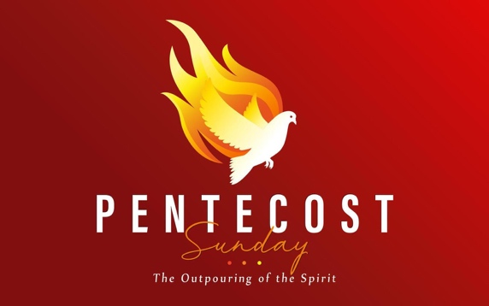
LifeBridge UMC: Discipleship Guide for Sunday 6-8-25

Read the Main Scriptures: Acts 1:8; Acts 2:1–13

1. Expecting Power
- Acts 1:8 promises power from the Holy Spirit. What kind of “power” do you think Jesus was talking about?
- What does it mean to be a “witness” in the context of this verse?
- Have you ever felt inadequate in your faith or witness? How does this verse encourage you?

2. The Pentecost Experience
- Describe what happened in Acts 2:1–4. Why do you think God chose such a dramatic way to send the Spirit?
- What do the “tongues of fire” and “rushing wind” symbolize?
- Why is it significant that people from many nations heard the message in their own language? What does this say about the nature of God’s mission?

3. Power with a Purpose
- What changed in the disciples after they received the Holy Spirit?
- How does the Holy Spirit empower us today?
- Do you feel like the Holy Spirit is active in your life? Why or why not?

Closing Prayer:
Dear God, Give me boldness, fresh empowerment, and sensitivity to the Holy Spirit in my daily life, Amen.

